**SQL Baseline using power BI – uploading perfmon Diagnostic data**

**Introduction**

In this document I will outline the steps that is required to create the database schema and how to populate the Power BI data model and create the charts.

**Creating the database schema**

Please run the below TSQL script to create the database schema.



***[Michael automation script will go here to create the ODBC connection]***

**Power Bi Data Model**

The Power BI data model has been created using the below tables and views.

**SQL table**

CounterDetails – Contains all the counter relevant information.

CounterData – Contains the counter data.

DisplayToID – Contains all the batch load date/time for the perfmon log file.

**SQL View**

CompareCounterData – this is for comparing the datetime period

CompareCounterDetail - this is for comparing the datetime period

vCounterDetails – This will return the Computer name and SQL instances.

Here is a diagram of the Power BI data model.

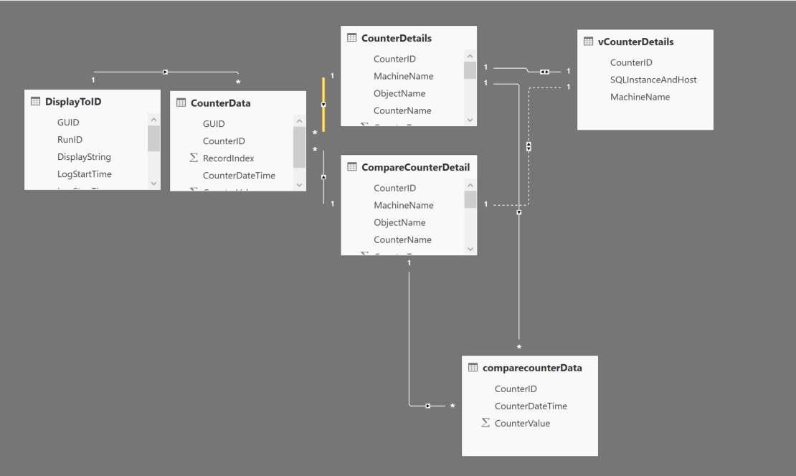

**PowerBi Table relationship:**

I have used the below relationship in the Power BI model

* DisplaToID – CounterData – 1 to many (GUID)
* CounterData – CounterDetails – Many to 1 (CounterID)
* CounterData – CompareCounterDetail – Many to 1 (CounterID)
* CompareCounterDetails – CompareCounterData – 1 to many (CounterID)
* CounterDetails – CompareCounterData – 1 to many (CounterID)
* CounterDetails – vCounterDetails – 1 to 1 (CounterID)

**Uploading the Perfmon files** *<this section will be taken out once we test Michael automation script, which should cover this step>*

Below script will upload the perfmon data into the SQL server. Please run the PowerShell Script in admin mode. Please make sure the share drive path/ filter file path is correct.



Below is an illustration of the process. The PowerShell script fetches the perfmon file and using the ODBC connection, relog process makes connection to the SQL server to upload data into the database tables. Once the file processing is complete you open Power BI desktop and refresh the data.

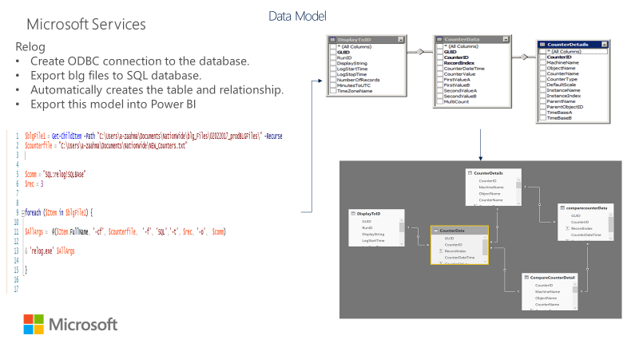

**Refresh the Data using Power BI**

Before you refresh the data, please make sure your source server is configured correctly.

**Check data source configuration**

Make sure you’re on the **Home** ribbon and then click on Edit Queries > Data Source Settings

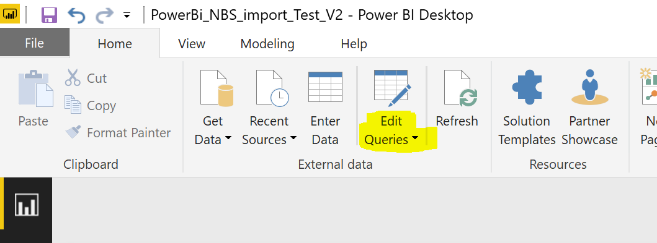

When you click on the **Data Source settings** the below window should prompt

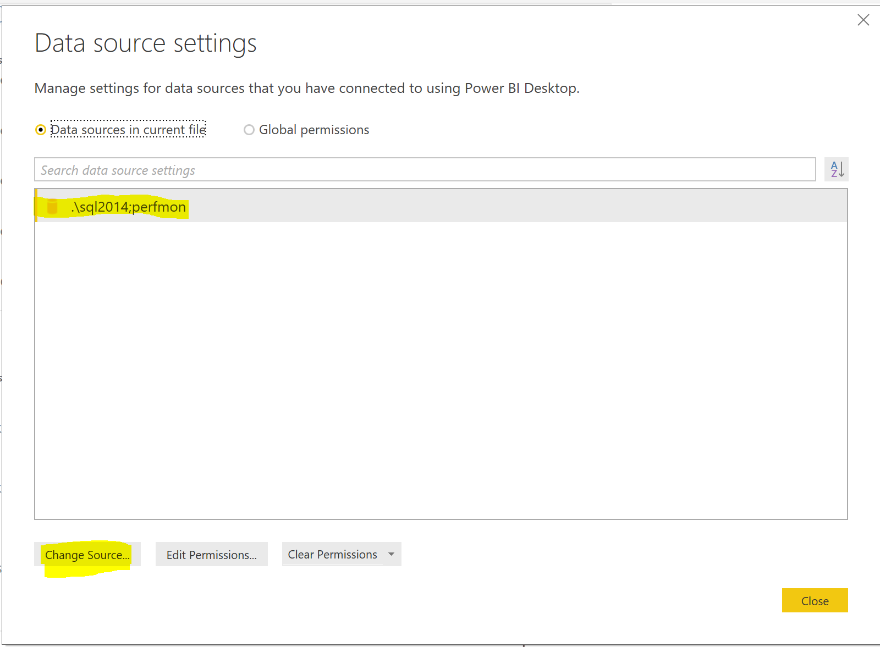

If the data source is different click on the **Change Source** and this will prompt below pop up to update the SQL server connection.

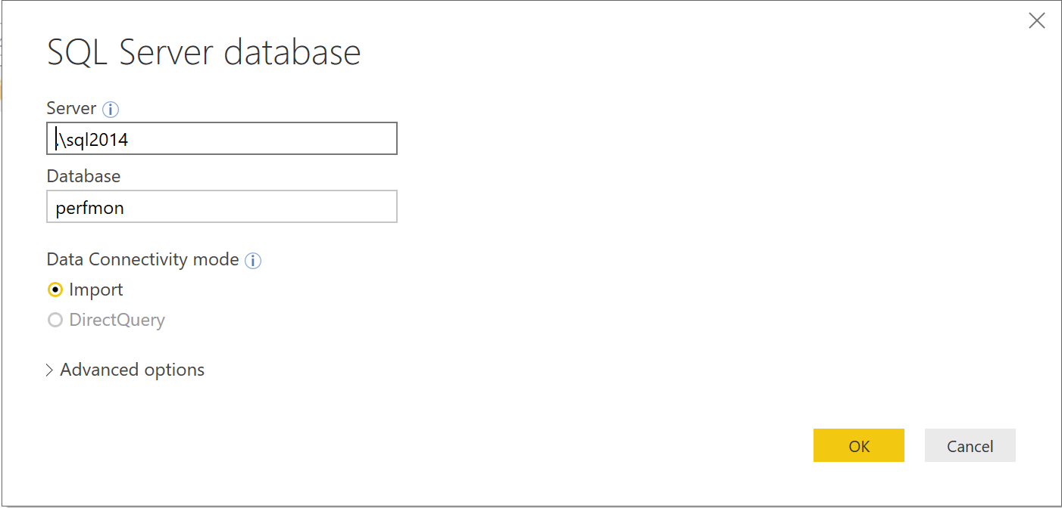

**Refresh Power BI data Model using Desktop version**

To refresh your Power BI data model, please click on the refresh button below highlighted on the **Home** ribbon.

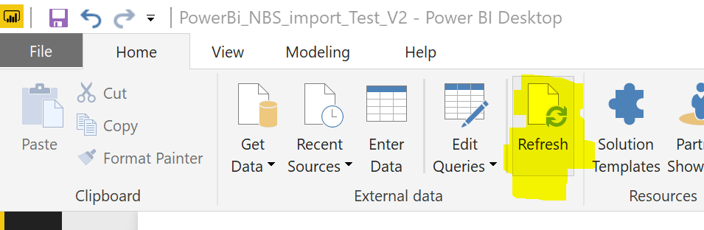

**Add a table/View to Power BI data model**

go to **Home** ribbon then click on **Get Data** > **SQL Server**

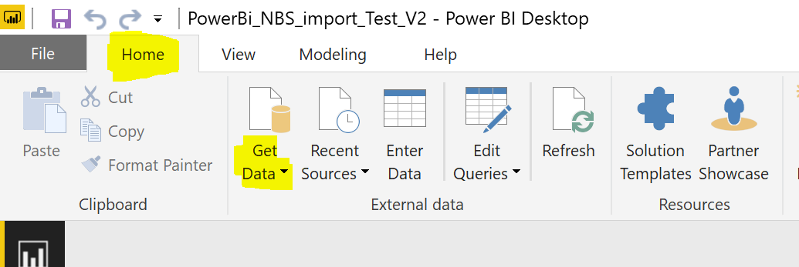

You will see the below pop up. Chose **import** for fast load.

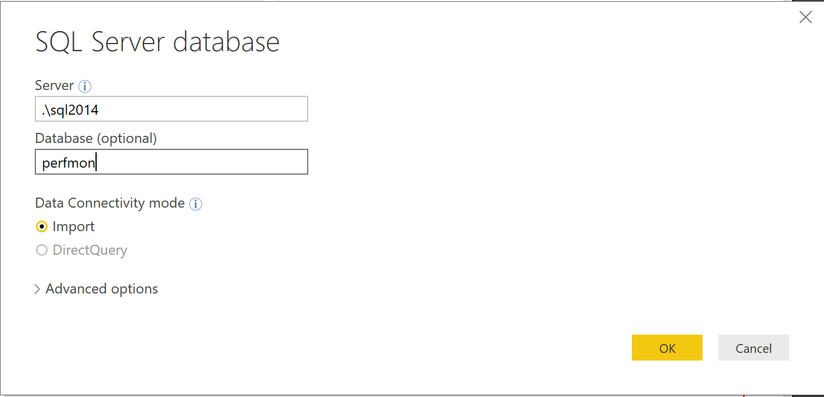

When you click **Ok** you should get another window popping up see below.

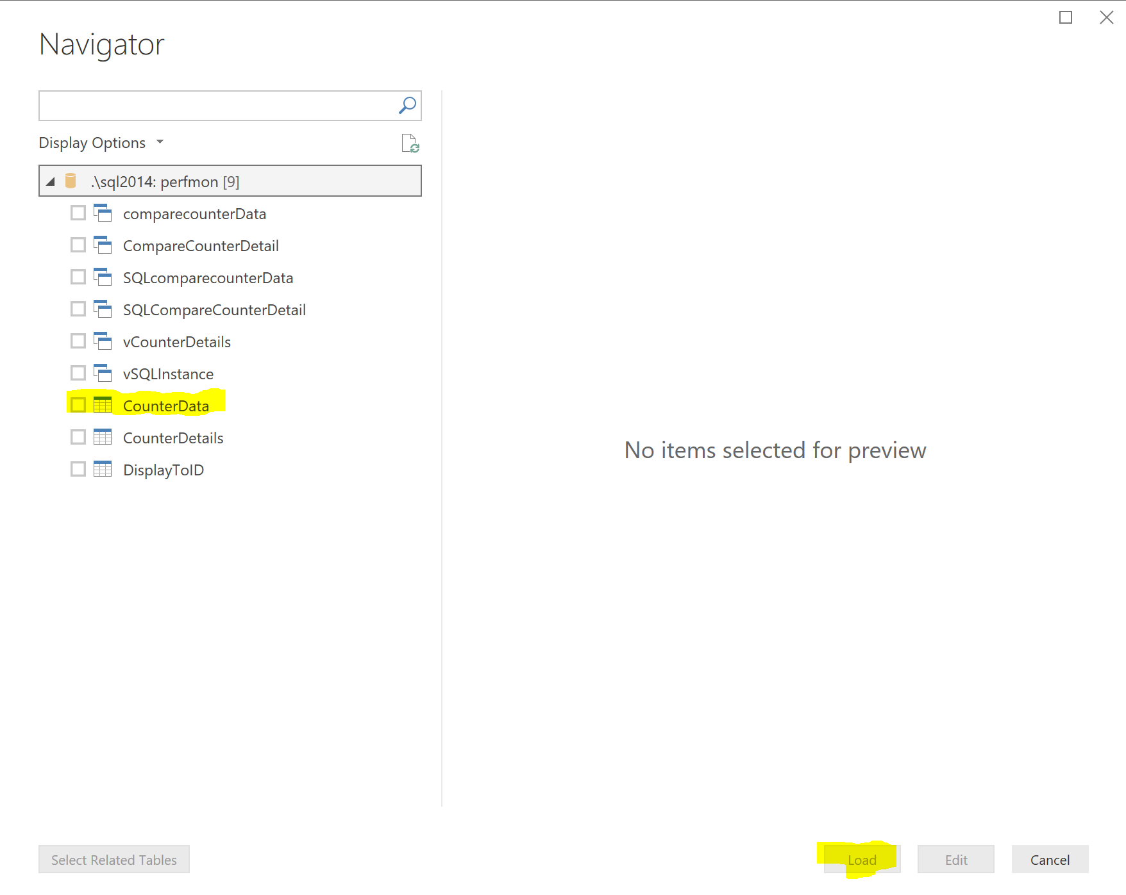

When you select the table and then click 

When you select the table/view then click **Load.** This should load the table into the power BI model and the table will appear on the right hand pane. Please see below.

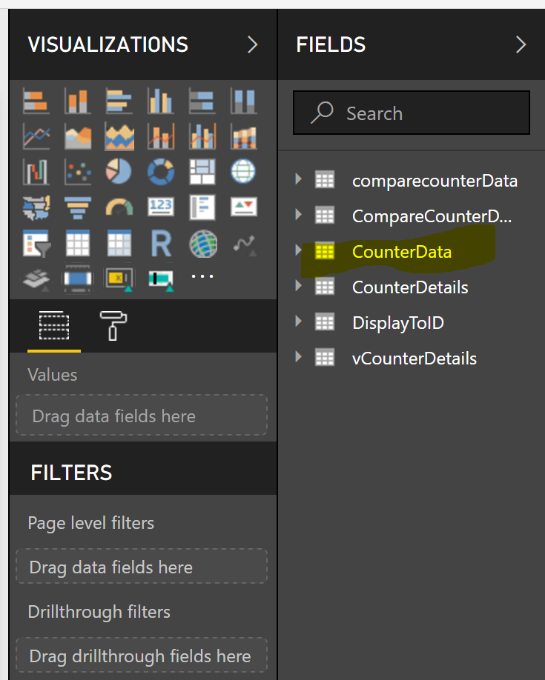

**Creating a new chart**

On **Home** ribbon select **New Visual**

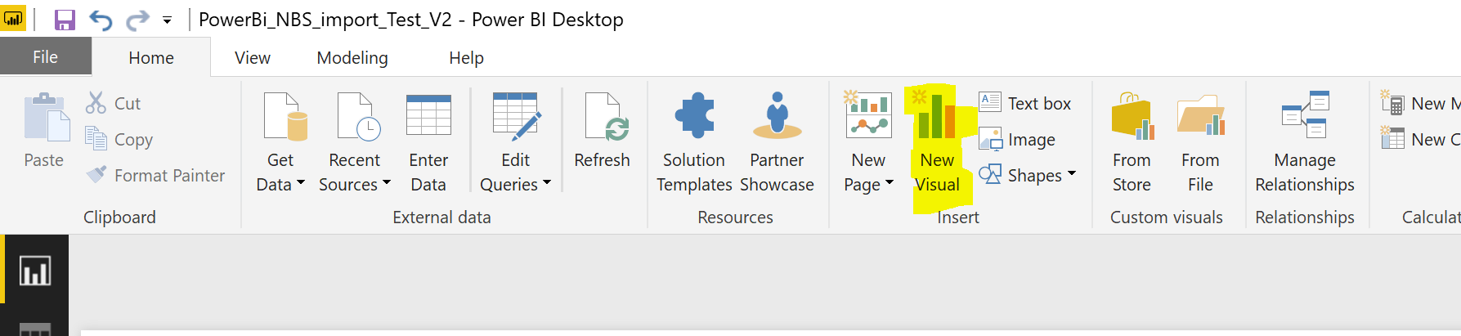

Select the **Chart**

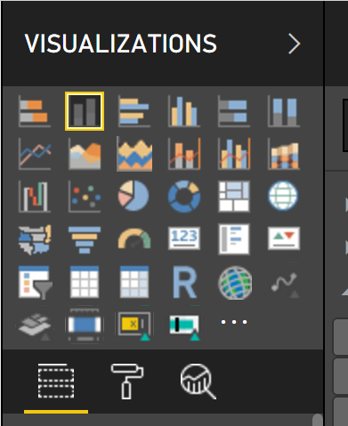

Expand the table column for **CounterData** and drag **CounterDateTime** to the **Axis** field. Follow below instruction.

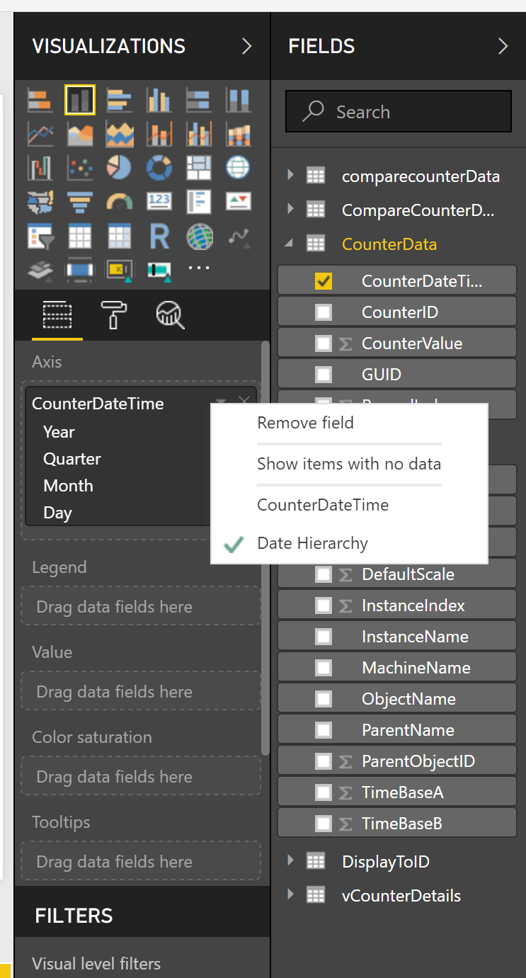

Change the CounterDateTime on **Axis** to **CounterDateTime** shown below.

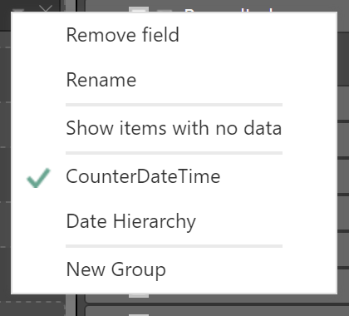

Please follow the below steps to complete the steps to create the charts.

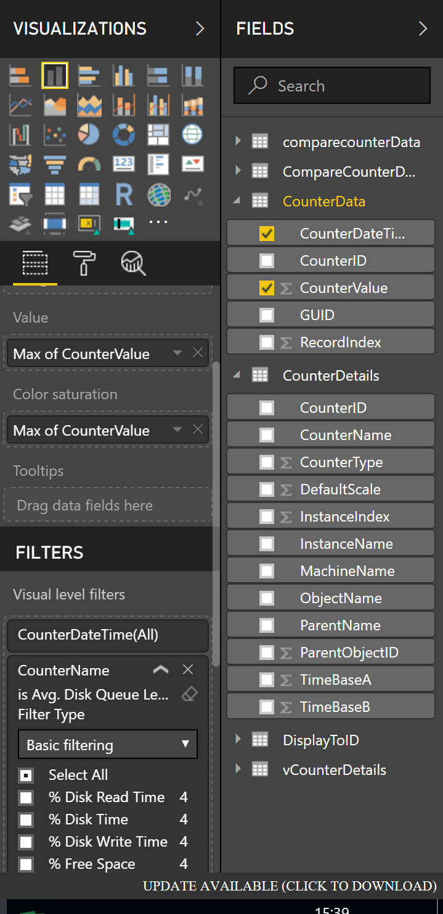

Drag the CounterName from CounterDetails table under Visual level filters and select the counter name you want to display the data.

Drag the countervalue **Colour Saturation** from CounterData table. This will enable the threshold. I will show at the next page how to set this up.

Drag the countervalue under **Value** from CounterData table.

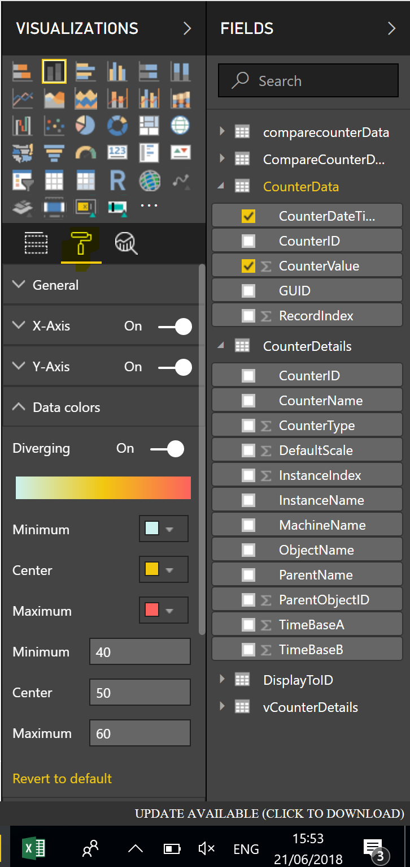

Choose the threshold limit.

Selecting different colour for the threshold.

Turn on **Diverging.**

Select the roller brush.

Finally, you can set the properties to add the Title and legend for the chart.

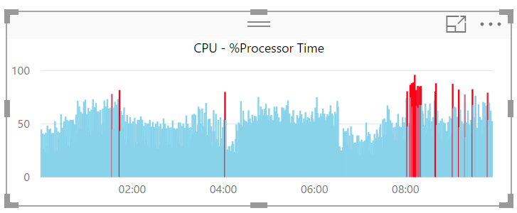

**Add Title to a chart**

Under the **Roller Brush** you will see a drop-down option for **Title.** You will need to turn that **On.**  Then update the text in the text box section highlighted.

